Dis-Eur-Germany-Hohlenstein-Stadel- Löwenmensch from

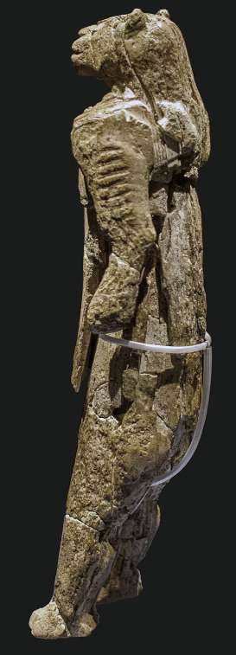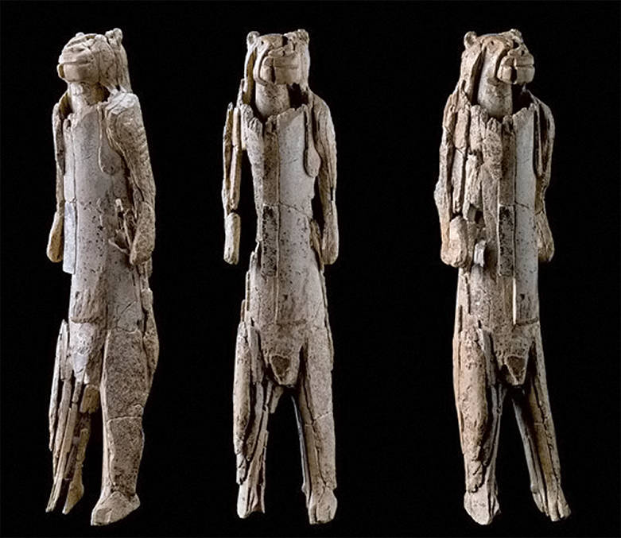

The Löwenmensch from Hohlenstein-Stadel. Height 30 cm, about 6 cm diameter. Made of mammoth ivory. Found in the cave of Hohlenstein-Stadel in the Valley of Lone, Baden-Wurttemberg (Germany), in 1931. Dated as Aurignacian, in a level now dated at 40 000 years old.  
  
Although this is known in some places as the lion lady, it is now known to be male. It is known as both Die Lowenfrau and Der Lowenmensch.  
  
The arms bear striations carved into the ivory. Years after the initial discovery the museum officials were presented with an ivory lion muzzle found in the cave. It was a perfect fit. Today it is pieced together from more than 1000 tiny pieces. This 'venus' may be an attempt to capture the power of the lion.   
  
Dimensions: height 281 mm, width 63 mm, thickness 59 mm.  
  
This is the best quality photo of the Löwenmensch before the recent discoveries of extra pieces and the subsequent restoration in 2012/2013.   
  
Photo: http://www.loewenmensch.de/lion_man.html

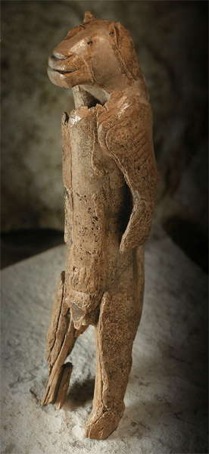

Discussion: Lion Man is a shaman in the process of spiritually (not physically) being transformed from his human self into the spirit of the powerful *Panthera leo spelaea* or Eurasian Cave Lion. Fragments of a piece were uncovered in 1939 on the very last day of excavation of the Hohlenstein-Stadel cave in the Lone valley. Archaeological activity was then disrupted by the commencement of World War II. More than thirty years later it was finally recognized that the ivory pieces were part of a figurine. Another two decades passed before experts restored the statuette. Restoration could only be partial, however, because significant sections had not yet been retrieved. In 2009 new excavations in the Hohlenstein-Stadel led to a re-discovery of the statuette’s previous location identified in 1939, and from that locus they were able to retrieve many more fragments. There followed a very complex project of reconstruction 2012-2013. The sculpture, comprises more than 300 fragments and reveals much more detail than had previously been possible. This has provided insights into some of the techniques involved in its creation, the statuette fuses animal and human elements: lion attributes are the head, elongated body and forelimbs, while human attributes are legs and feet in a bi-pedal stance and the genital area signifying maleness.